

ACTIVITY KIT PRESCHOOL

 | Picture | Description
 | 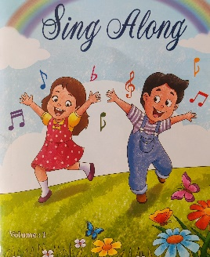 | English Rhyme Book volume 1
 | 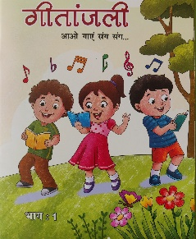 | Hindi Rhyme Book volume 1
 | 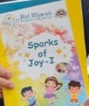 | Sparks of Joy-I (Activity Book)
 | 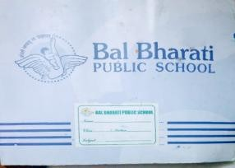 | Sketch Book (ONLY 1)
 | 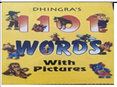 | 1101 Words Yellow book with pictures
 | 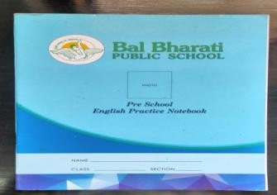 | English Practice Notebook
 | 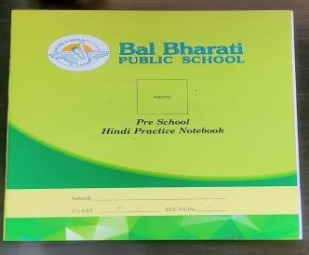 | Hindi Practice Notebook
 | 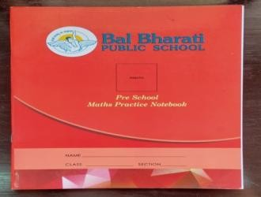 | Maths Practice Notebook
 | 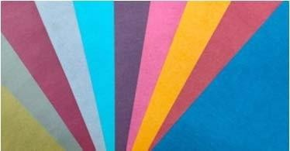 | Colour Pastel Sheets A4(1Packet180‐200gms20Sheets)
 | 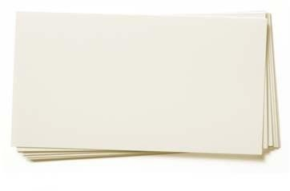 | Ivory Sheets A4 20 Sheets
 | 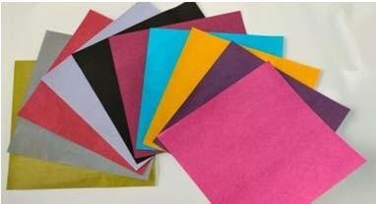 | Origami Sheets Bright colours Plain 6x6"70gms 20 Sheets
 | 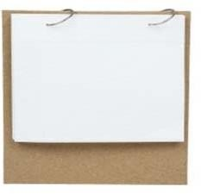 | Photo Calendar7x3"or6x8"1/2A4sheets
 |  | Weighing scale
 | 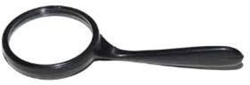 | Magnifying Acrylic
 | 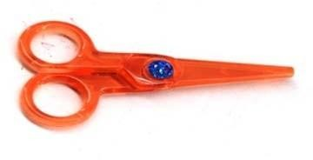 | Scissors
 | 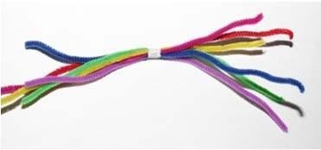 | Velvet Wire 6pcs
 | 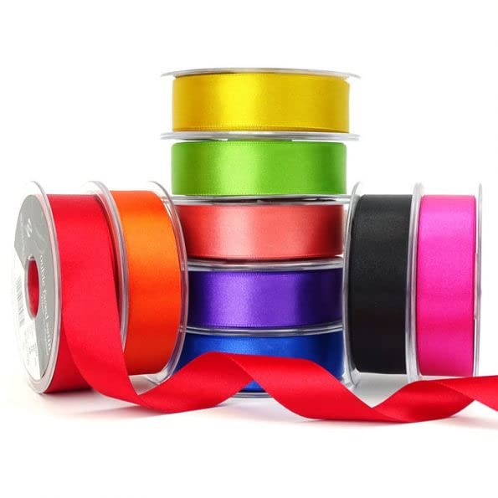 | Satin Ribbons 1roll, (Any 2 Colours)
 | 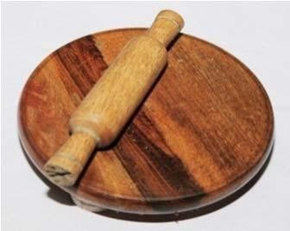 | Rolling pin wooden Small
 | 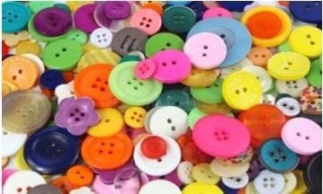 | Mixed Buttons Coloured 12 in a pack
 | 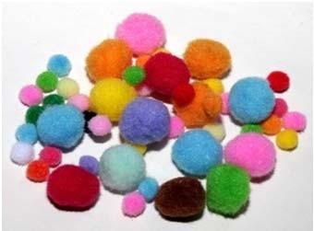 | Cotton Balls Pompom -1 Big Pkt
 | 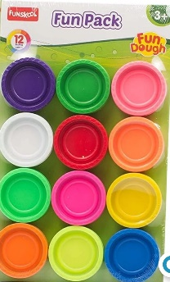 | Funskool Fun dough Box of Colours, 12 tubs of Multicolour Dough, 50gms Each
 | 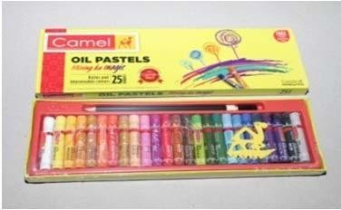 | Oil Pastel Wax Crayons 24 shades 2 Boxes
 | 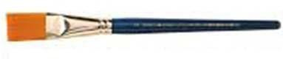 | Paint Flat Brush 8 no.1Pc
 | 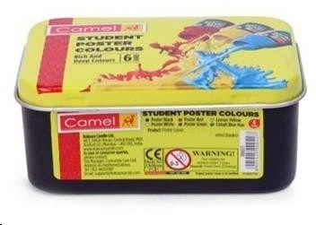 | Poster colour Box 6 shades separate
 | 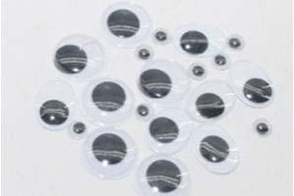 | Googly Eyes assorted sizes15 pairs
 | 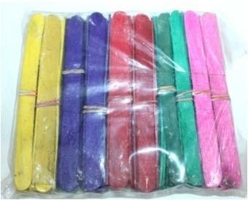 | Ice Cream Sticks (1 small pkt)
 | 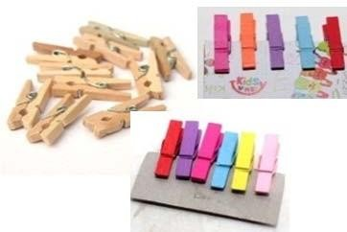 | Wooden12 pcs small Pegs
 | 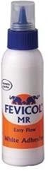 | Small Tube Fevicol100 gms-2Pcs
 | 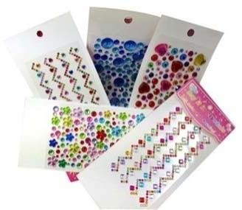 | Studs/sequins round sticker1Pkt -24 Pcs
 | 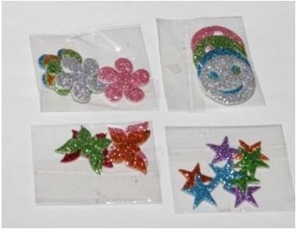 | Glittery stickers (Star,Flower,Smiley,& Butterfly10+10pcs)  Assorted Stickers Smiley and Stars
 | 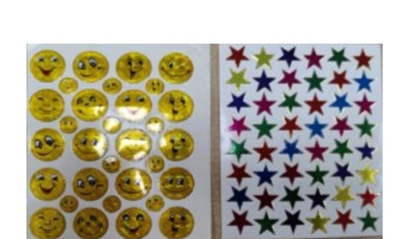 | Assorted Stickers Smiley and Stars
 | 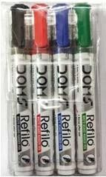 | White Board marker 2Black/1Red/1Blue/1 Green
 | 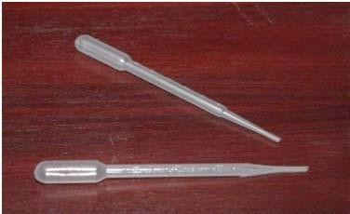 | Dropper 1 Simple
 | 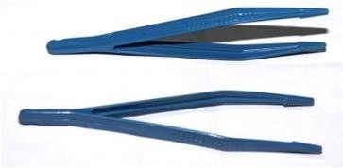 | Tong Plastic-1
 | 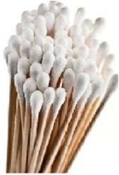 | Ear buds-small pack
 | 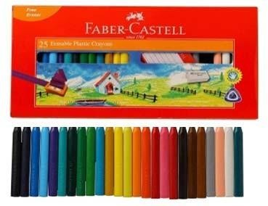 | Grip Crayons Wax Crayon‐Plastic fabercastell10pcs
 | 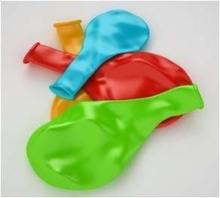 | Balloons
 | 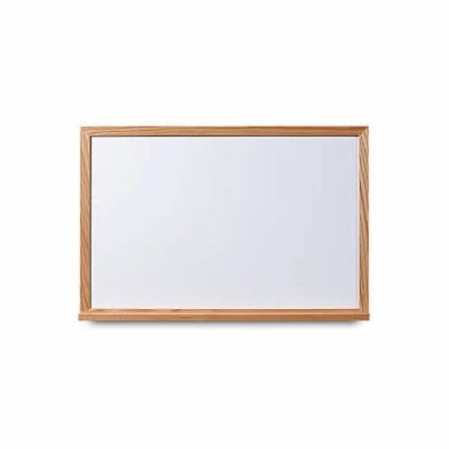 | Slate (1 side white 1 side Green )
 | 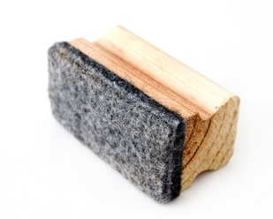 | Duster (Small)
 | 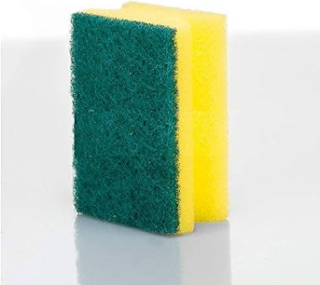 | 2 in 1 Cleaning Scrub and Sponge for kids (Small size)
 | 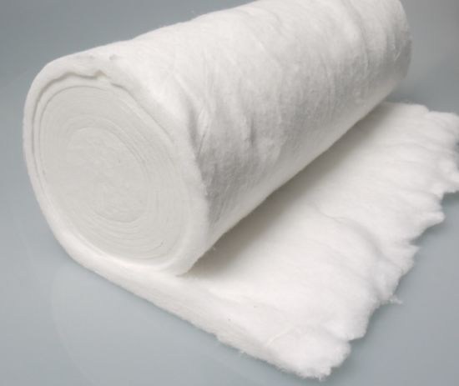 | Cotton roll
 | 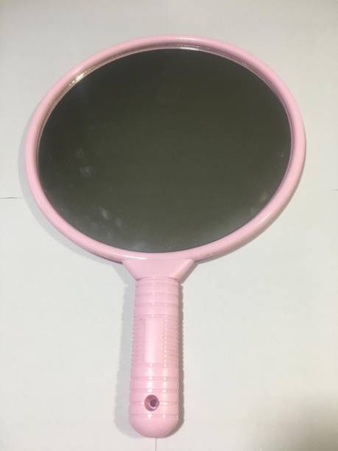 | Mirror
 | 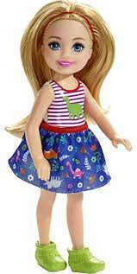 | Doll
 | 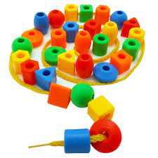 | Stringing beads pouch with thread (12 beads)
 | 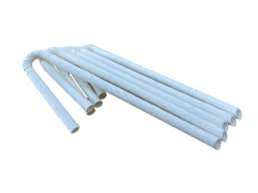 | Straws ( Pack of 6)
 | 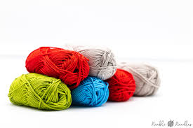 | Wool Roll (Only 1 roll of wool)
 | 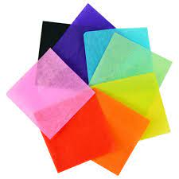 | Crepe paper
 | 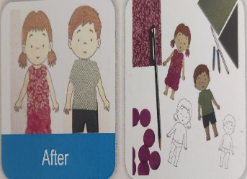 | DIY Dress Me Up (KW- M11)
 | 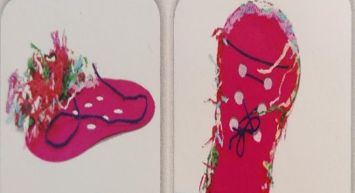 | DIY Lacing Shoe (KW- M59) NEW
 |  | Squeezy Ball
 | 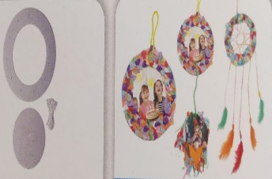 | Hanging Dream Catcher Round (KW-005)
 | 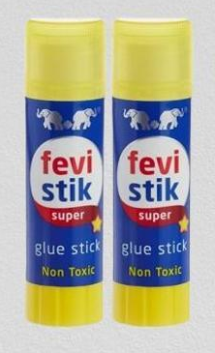 | Fevistick 2 pcs
 | 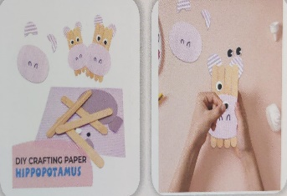 | DIY Crafting Paper HIPPO (KW – M43)
 | 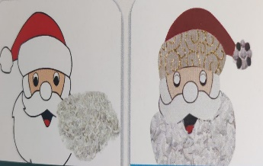 | Santa Mask (KW- 1040C)
 | 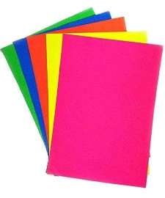 | Assorted Coloured Fluorescent thin A4 sheets
 | 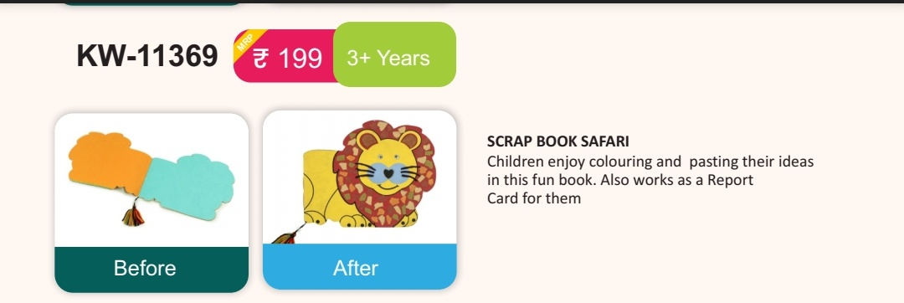 | Scrap Book Safari
 | 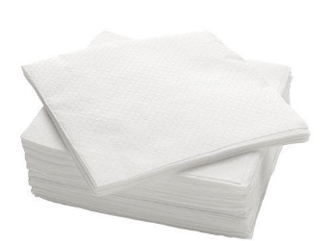 | Tissue Paper 1 pkt.
 | 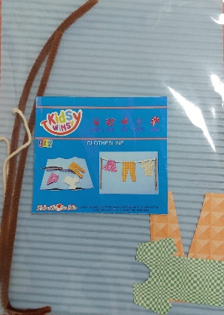 | DIY Clothesline
 | 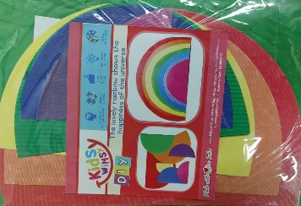 | DIY Lovely Rainbow
61. | 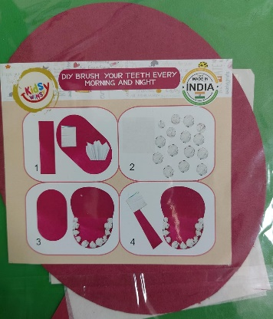 | DIY Brush Your Teeth Every Morning and Night
62. | 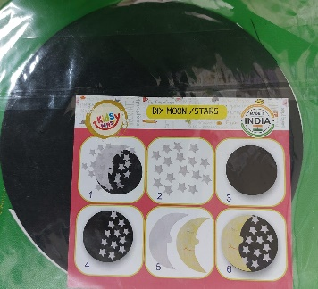 | DIY Moon / Stars
63. | 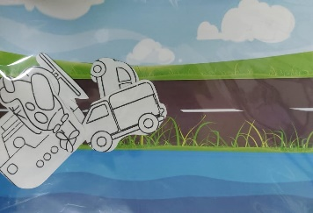 | Means of Transport
64. | 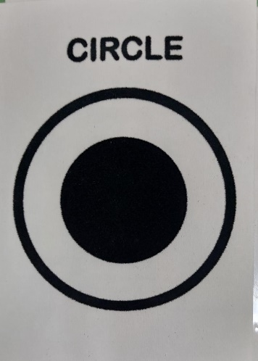 | Basic Shapes Tracing  Number Tracing Cards
65. | 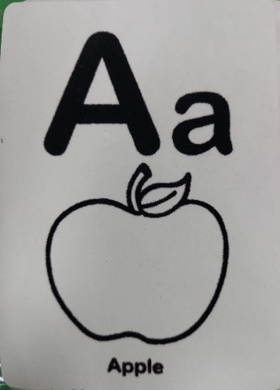 | Alphabets Tracing And Colouring
66 |  | Number Tracing Cards
67 | 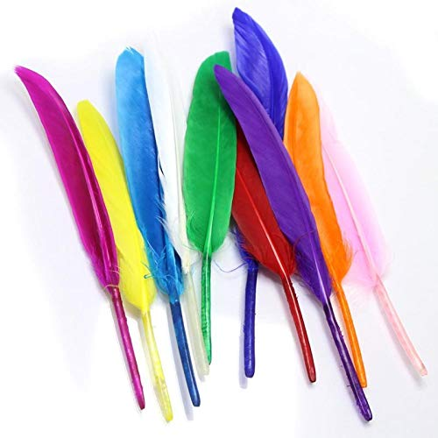 | Artificial Feathers for Craft 1 pack

