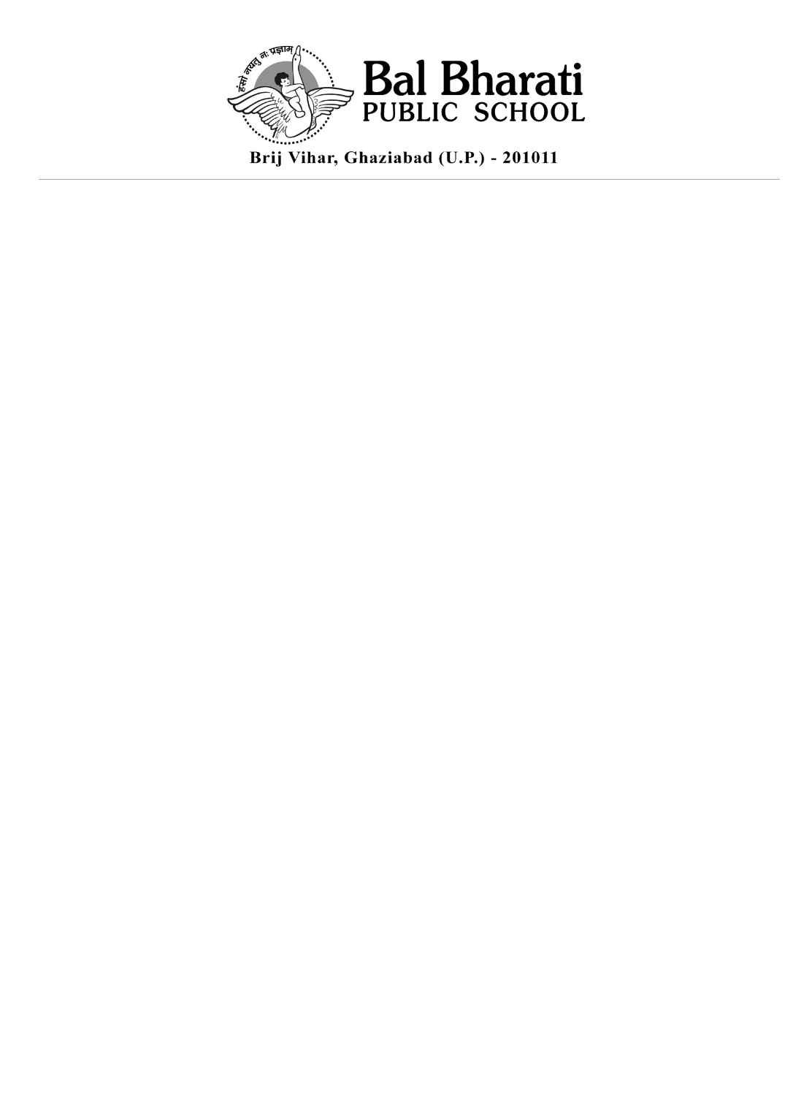
CLASS II-BOOKLIST (SESSION 2024-25)
TEXTBOOKS
S.No | Subject | Name of the Book | Publisher
1 | English | Tip Tap Toe English Course Book 2 | Pearson
1 | English | Tip Tap Toe English Practice Book 2 | Pearson
1 | English | Tip Tap Toe Supplementary Reader 2 | Pearson
2 | Hindi | Nai Aashayein (Part -II) | P.P. Publication
2 | Hindi | Nai Aashayein (Workbook) | P.P. Publication
3 | Maths | Mathematics-II | BBPS Training Centre
3 | Maths | Shin Program Activity Book II | Shin Edupower
3 | Maths | Wise Time Maths Tool Kit
4 | EVS | Viva Environment Studies Part -II | Viva Education
5 | Computers | IT planet code book -II | PMP Planet Multimedia publisher.
6 | GK | Did you know? Level II | Cambridge University Press
7 | Art & Craft | Art Express (Art & Craft Book II) | P.P. Publication
8 | Karadi Path Magic English Junior Programme | Magic English Junior Level II | Karadi Path

