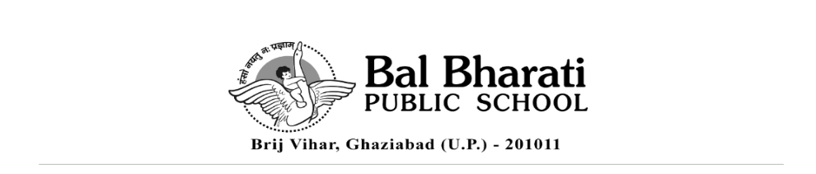
Circular No. BBPSBV/05-25 Date: 10 April, 2025

Dear Parents

Kindly note the following points very carefully.

*Students must come to school in proper and complete uniform.

- They are not allowed to wear any jewellery/ expensive accessories in school. If they are caught with any such item, it will be confiscated.
- Their nails should be trimmed. Nail paints are not allowed.
- Boys should have a short and neat haircut. Girls' hair should be neatly tied.

* Late coming to the school is strictly not allowed. The students will be sent back home if they are late, even on examination days.

* Half days/short day leaves are not allowed for students. In case of an emergency, if they are taken back, they will be marked absent for the whole day.

* Tiffins and water bottles are not to be left in the guard room. School will not be responsible for delivering them in the class of your ward. This is for the safety and security of your ward.

* Mobiles are strictly not allowed for the students. If found, the same will be confiscated and returned at the end of the session. In case of an emergency, special permission has to be taken by the departmental head.

Kindly adhere to the above instructions.
We look forward to your cooperation.

Regards
Swapna Nair
Principal

