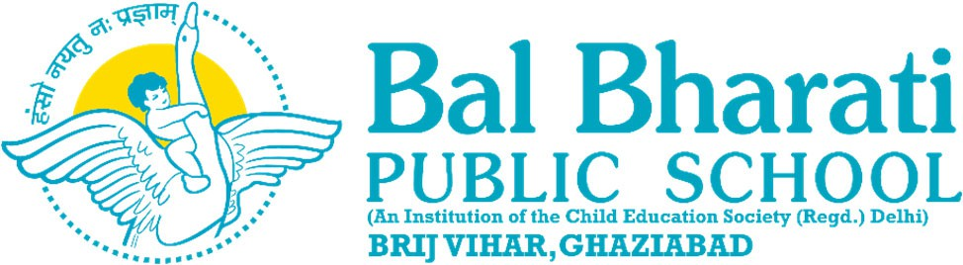

Circular No. BBPSBV/08-25 Date: 16 April, 2025

Dear Parents
We are pleased to inform you that we have initiated new bus routes for the convenience of our students,w.e.f. 1st April, 2025.
The buses plys on the following new routes-
1. Mohan Nagar
2. Siddharth Vihar
3. Dilshad Garden
4. Shahdara
5. Raj Nagar Extension
6. Rajendra Nagar
These routes have been planned to ensure safer and efficient transportation for our students.
Interested parents may send their written consent through WhatsApp to the respective class teachers at the earliest.

